**How to get input from user**

**import** java.util.Scanner;

**class** GetInputFromUser

{

**public** **static** **void** main(String args[])

{

**int** a;

**float** b;

String s;

Scanner in = **new** Scanner(System.in);

System.out.println("Enter a string");

s = in.nextLine();

System.out.println("You entered string "+s);

System.out.println("Enter an integer");

a = in.nextInt();

System.out.println("You entered integer "+a);

System.out.println("Enter a float");

b = in.nextFloat();

System.out.println("You entered float "+b);

}

}

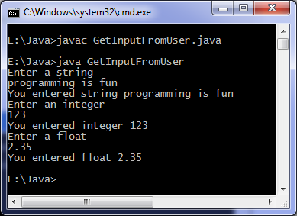

# Java program to find odd or even

**import** java.util.Scanner;

**class** OddOrEven

{

**public** **static** **void** main(String args[])

{

**int** x;

System.out.println("Enter an integer to check if it is odd or even ");

Scanner in = **new** Scanner(System.in);

x = in.nextInt();

**if** ( x % 2 == 0 )

System.out.println("You entered an even number.");

**else**

System.out.println("You entered an odd number.");

}

}

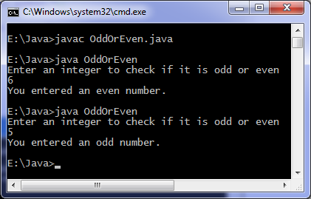

# Java program to [convert Fahrenheit to](http://www.cgstatic.info/code/r.php?r=yahoo%7Cconvert%2520Fahrenheit%2520to&t=39&did=39&uid=0&type=bl&subid=raftxXYZcay%24&rkw=convert+Fahrenheit+to&rurl=http%3A%2F%2Fwww.programmingsimplified.com%2Fjava%2Fsource-code%2Fjava-program-to-convert-fahrenheit-to-celsius&domain=programmingsimplified.com&lnktype=10&v=0.126&browser=Firefox_44&country=IN&_=1458447700171) Celsius

**import** java.util.*;

**class** [FahrenheitToCelsius](http://www.cgstatic.info/code/r.php?r=yahoo%7CFahrenheitToCelsius%2520&t=39&did=39&uid=0&type=bl&subid=raftxXYZcay%24&rkw=FahrenheitToCelsius&rurl=http%3A%2F%2Fwww.programmingsimplified.com%2Fjava%2Fsource-code%2Fjava-program-to-convert-fahrenheit-to-celsius&domain=programmingsimplified.com&lnktype=10&v=0.126&browser=Firefox_44&country=IN&_=1458447706672) {

**public** **static** **void** main(String[] args) {

**float** temperatue;

Scanner in = **new** Scanner(System.in);

System.out.println("Enter temperatue in Fahrenheit");

temperatue = in.nextInt();

temperatue = ((temperatue - 32)*5)/9;

System.out.println("Temperatue in Celsius = " + temperatue);

}

}

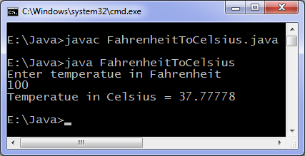

# Java methods

**class** Methods {

*// Constructor method*

Methods() {

System.out.println("Constructor method is called when an object of it's class is created");

}

*// Main method where program execution begins*

**public** **static** **void** main(String[] args) {

staticMethod();

Methods object = **new** Methods();

object.nonStaticMethod();

}

*// Static method*

**static** **void** staticMethod() {

System.out.println("Static method can be called without creating object");

}

*// Non static method*

**void** nonStaticMethod() {

System.out.println("Non static method must be called by creating an object");

}

}

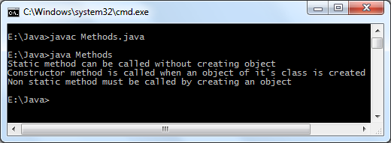

## Java String methods

**class** StringMethods

{

**public** **static** **void** main(String args[])

{

**int** n;

String s = "Java programming", t = "", u = "";

System.out.println(s);

*// Find length of string*

n = s.length();

System.out.println("Number of characters = " + n);

*// Replace characters in string*

t = s.replace("Java", "C++");

System.out.println(s);

System.out.println(t);

*// Concatenating string with another string*

u = s.concat(" is fun");

System.out.println(s);

System.out.println(u);

}

}

